**Installing Older Versions of Cloudera Manager 5**

<https://www.cloudera.com/documentation/manager/5-1-x/Cloudera-Manager-Installation-Guide/cm5ig_install_older_cm5.html>

1-#sudo -i

2-#wget http://archive.cloudera.com/cm5/redhat/6/x86_64/cm/cloudera-manager.repo

3-#vi cloudera-manager.repo

baseurl=http://archive.cloudera.com/cm5/redhat/6/x86_64/cm/5.0.1/ (change desire ver like 5 to 5.12.1)

4-#cp cloudera-manager.repo /etc/yum.repos.d/

5-#sudo yum install oracle-j2sdk1.7

6-#sudo yum install cloudera-manager-daemons cloudera-manager-server

7-#sudo yum install cloudera-manager-agent cloudera-manager-daemons

8-#sudo yum install cloudera-manager-server-db-2

------------------------------------------------------

**Prerequisite-**

service iptables stop

cat /etc/sysconfig/selinux

sysctl -w net.ipv6.conf.all.disable_ipv6=1

sysctl -w net.ipv6.conf.default.disable_ipv6=1

sudo sysctl -w vm.swappiness=0

echo never > /sys/kernel/mm/redhat_transparent_hugepage/enabled

-------------------------------------------------------

Restart node

9-#sudo service cloudera-scm-server-db start

10-#sudo service cloudera-scm-server start

11-#sudo service cloudera-scm-agent start

Then Use publib IP of this node access the CM**(Public IP:7180)**

etc/cloudera-scm-agent/config.ini ->Name of host where the Cloudera Manager Server is running.

ls -ll /var/lib/cloudera-scm-server-db/

chown -R root:root /var/lib/cloudera-scm-server-db

========================================================

# lsof -i | grep LISTEN | grep cloudera-scm

java 78425 cloudera-scm 248u IPv4 2129825 0t0 TCP *:7180 (LISTEN)

===================================================================================== df -Ph

free

**Clooudera Manager Upgrade**

###################################################################################

Need to upgrade CM 5.12.1 to 5.13.1.

1. Need to create local Repository
2. On CM-> wget <http://archive.cloudera.com/cm5/repo-as-tarball/5.13.1/cm5.13.1-centos6.tar.gz>

**Note**-u can check the CM node by this command**. # cat /etc/cloudera-scm-agent/config-ini**

1. #tar xzvf **cm5.13.1-centos6.tar.gz –C /var/www/html** (can be any location)
2. Need to edit repos file on each machines: #**vi /etc/yum.repos.d/ cloudera-manager.repo**

baseurl=http://archive.cloudera.com/cm5/redhat/6/x86_64/cm/5.**13**.1/ **(change desire ver)**

**Note**-before change this file need to take backup

1. **#yum clean all** & **#yum makecache (on all nodes)**
2. **Stop** the cluster
3. **Stop** the cloudera manager services
4. **Logout** from the web UI
5. **# service cloudera-scm-server stop** & **# service cloudera-scm-agent stop (on CM node)**
6. **# service cloudera-scm-agent stop (on agent nodes)**
7. Please take the data backup of databases.
8. #yum list all | grep cloudera
9. #yum –y upgrade cloudera-manager-server cloudera-manager-daemons cloudera-manager-server-db-2 cloudera-manager-agent **(on CM)**
10. **#** yum –y upgrade cloudera-manager-daemons cloudera-manager-agent **(on agents)**
11. #service cloudera-scm-server start **&** #service cloudera-scm-agent start **(on CM)**
12. **#**service cloudera-scm-agent start **(on agents)**
13. Now access the CM thru WebUI
14. 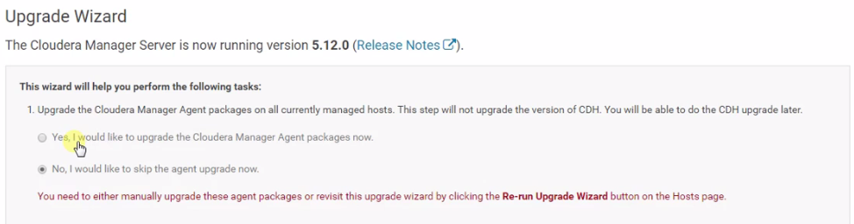
15. Then continue-> continue->finish
16. Start the cluster
17. Now to go Support->about and check your CM is upgraded.

**Backup Database**

sl73caehmp11

mysqldump -uroot -p --databases hue metastore oozie > /hadoop01/Qualys/mysqldump_10172017.sql

sl73caehmp10

mysqldump -uroot -p --databases rman amon hmon sentry scm > /hadoop01/Qualys/mysqldump_10172017.sql

**Backup Metadata**

tar -cvf /hadoop01/Qualys/nn_backup_10172017.tar /hadoop01/dfs/nn

**===========CDH Upgrade =====================**

1-Download latest version of CDH

2-copy downloaded file to **etc/yum.repos.d/cm_121.repo**

**OR**

1. Go to the parcels->check the **Available Remotely** in **Status** Column.
2. Click on **Download** in **Actions** Column.
3. Click on **Distribute** in **Actions** Column
4. Click on **Upgrade** in **Actions** Column
5. 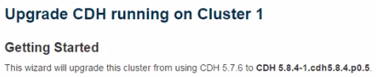
6. Take the backup of Metadata & Database
7. 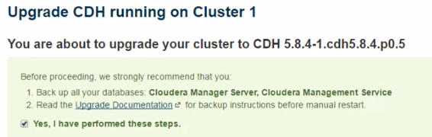
8. 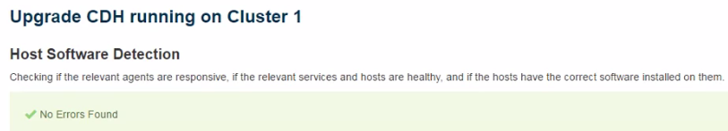
9. 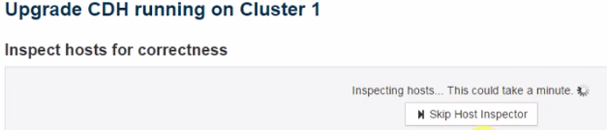
10. 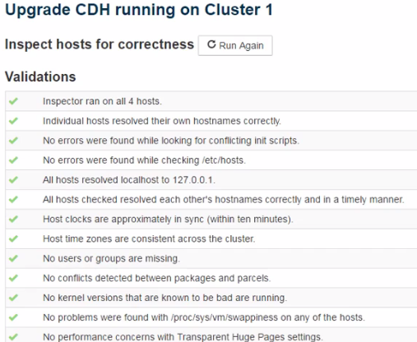
11. 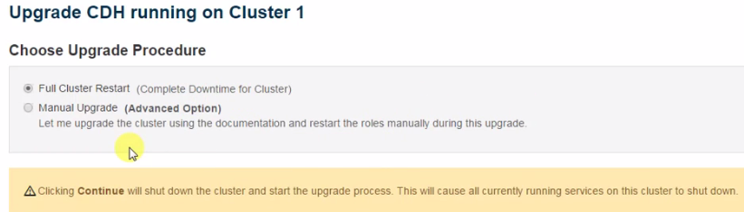
12. 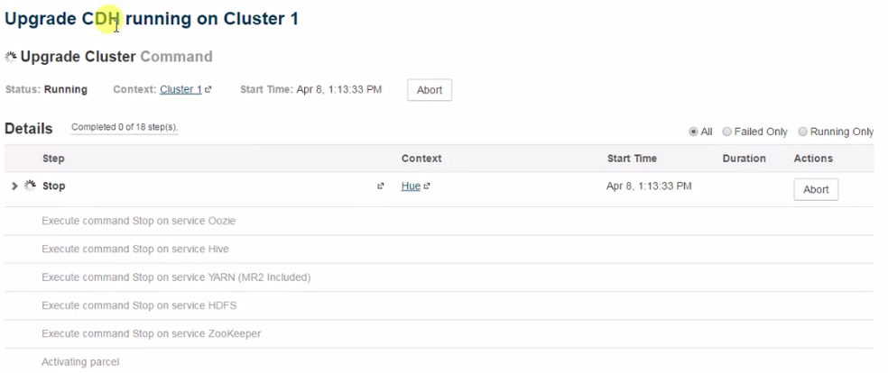
13. 